V**Client : site 1**

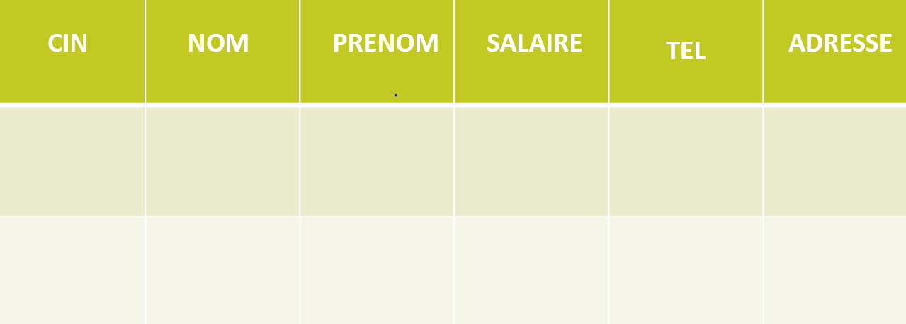

vclient1 site1



vclient2 site 1



vclient3 site1



VECHANGE site 1

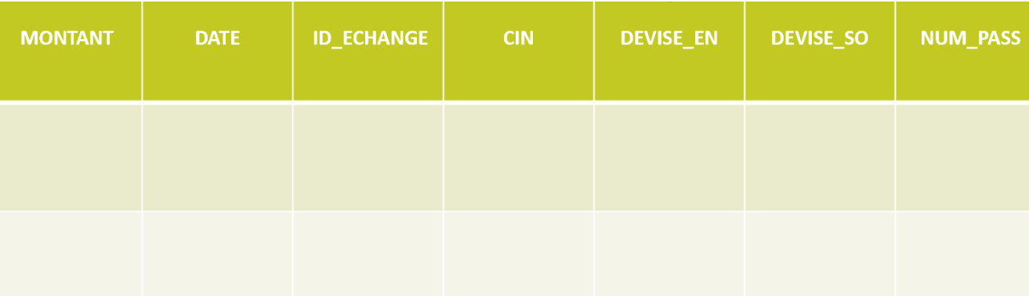

VDEPOSER s1 s2 s3

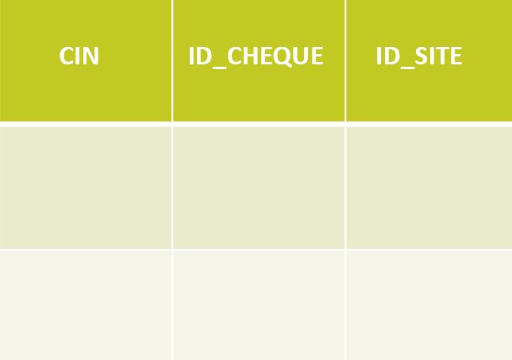

VSITE s2 s3

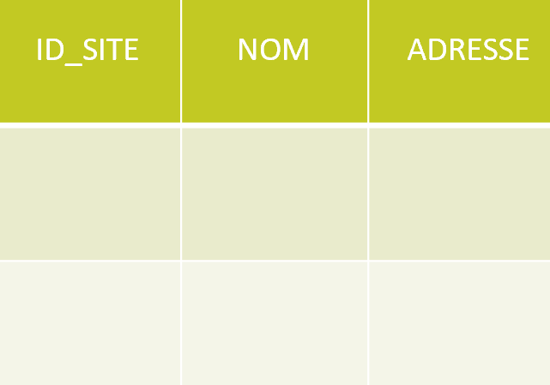

vpersonne s2 s3

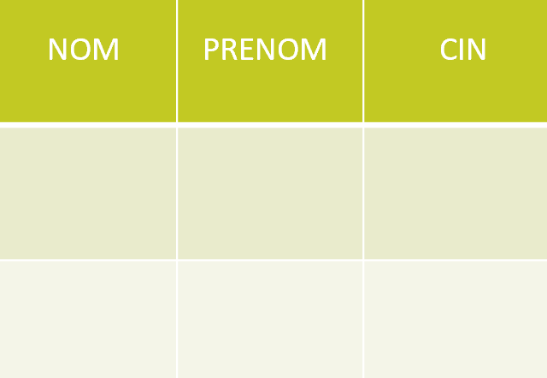

MATERIALIZED VIEW : MVCOMPTE s1

